**Hyperparameter Search: Grid search and random search:**Gird search is technique we use to search best hyper parameter by using train and CV data. In Logistic regression, lambda is hyperparameter. Also grid search called as brute force. So, in logistic regression, examples of Lambda values are [0.001,0.01,0.1,1,100,1000]. The reason we take this value is in LR, lambda , we take real valued numbers. We can vary this value, this is just an assumption.

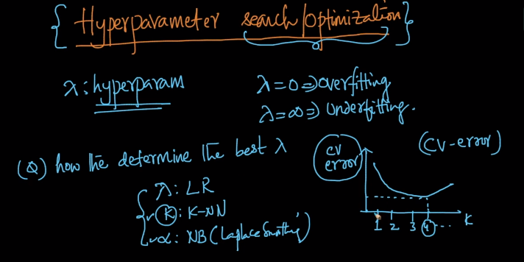  
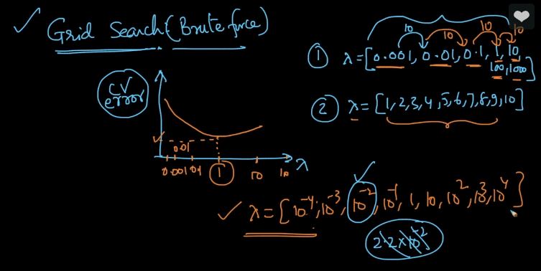  
So instead of simple logistic regression, let’s say we have elastic net logistic regression. Here we use L1 and L2 norms. So, we need to find the two Lambda values.  
**Steps:**  
Let’s say we have M1 values in Lambda 1 and M2 values in Lambda 2  
1) First we need to calculate the values of lambda1 and Lambda 2  
2) Plot M1 and M2 in a grid as show in figure. The number of possibilities on plot are M1 * M2   
3) This is called grid search because we are searching on grid of possibilities  
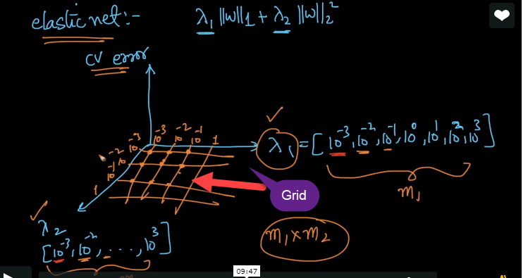   
There is problem with grid search i.e., As number of hyper parameters increase, the models needs to be trained increases exponentially because we can have any number of lambda’s. So, grid search is not good if there are many numbers of Lambda values. In deep learning, we can have any number of Lambda parameters.  
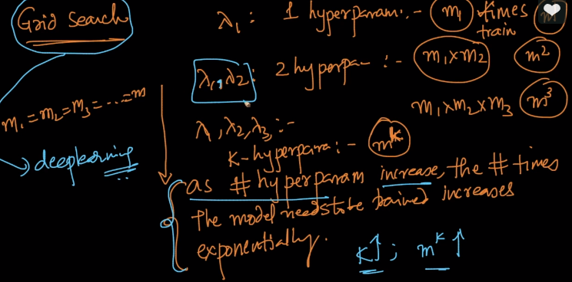  
To avoid this issue, we have other technique called random search.  
**Random Search:**Random search is good when number of hyperparameters are very large. In Random search, picking values will be done randomly in the given interval and give the result and plot.  
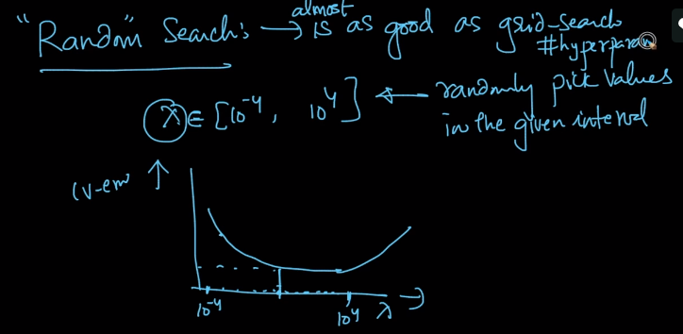  
This entire process is called hyperparameter search/ Optimization. Both of them are available in Scikit-Learn.